Name: Abhishek Kumar

**Module 2: Installation and Maintenance of Hardware and Its Components**

**Section 1: Multiple Choice**

1. Which of the following precautions should be taken before working on computer hardware?

a) Ensure the computer is plugged in to prevent electrostatic discharge.

b) Wear an anti-static wrist strap to prevent damage from electrostatic discharge.

c) Work on carpeted surfaces to prevent slipping.

d) Use magnetic tools to handle components more easily

**Ans:** b) Wear an anti-static wrist strap to prevent damage from electrostatic discharge.

**Explanation:-** Before working on computer hardware, static electricity from your body can damage sensitive parts inside the computer. To prevent this:

* Wear an anti-static wrist strap: It safely removes static electricity from your body.

2. What is the purpose of thermal paste during CPU installation?

a) To insulate the CPU from heat.

b) To provide mechanical support for the CPU.

c) To improve thermal conductivity between the CPU and the heat sink.

d) To prevent the CPU from overheating.

**Ans:** c) To improve thermal conductivity between the CPU and the heat sink.

**Explanation:** When installing a CPU, thermal paste helps to transfer heat from the CPU to the heat sink.

* The CPU and heat sink are not perfectly smooth, so there are tiny air gaps.
* Thermal paste fills those gaps and helps the heat move better from the CPU to the heat sink.

3. Which tool is used to measure the output voltage of a power supply unit (PSU)?

a) Multimeter

b) Screwdriver

c) Pliers

d) Hex key

**Ans:** a) Multimeter

**Explanation:** To check the **voltage** coming from a power supply unit, you need a multimeter.

* A multimeter is a tool that measureselectricity like voltage, current, etc.
* It helps you know if the power supply is working correctly.

4. Which component is responsible for storing BIOS settings, such as date and time, even when the computer is powered off?

a) CMOS battery

b) CPU

c) RAM

d) Hard drive

**Ans:** a) CMOS battery

**Explanation:** The CMOS **battery** is a small battery on the motherboard.

* It **stores BIOS settings** like **date, time, and** hardwaresettings.
* Even when the computer is turnedoff, this battery keeps the settings saved.

**Section 2: True or False**

5. True or False: When installing a new hard drive, it is essential to format it before use.

**Ans:** True

6. True or False: A POST (Power-On Self-Test) error indicates a problem with the CPU.

**Ans:** False

7. True or False: It is safe to remove a USB flash drive from a computer without ejecting it first.

**Ans:** False

**Section 3: Short Answer**

8. Describe the steps involved in installing a new graphics card in a desktop computer.

**Ans:** Step to Install a new graphic card.

* Turn off the computer and unplug it from the power.
* Open the computer case.
* Remove the old graphics card.
* Insert the new graphics card into the PCIe slot.
* Secure the card with a screw to hold it in place.
* Connect power cables.
* Close the case and plug in the computer.
* Turn on the PC and install drivers for the new graphics card.

1. What is RAID, and what are some common RAID configurations?

Ans: RAID stands for Redundant Array of Independent Disks.  
It is a data storage technology that joins two or more drives (HDD or SSD) to work together as a single system

Uses: big storage space, batter performance, Redundancy (data backup/duplication), Parity (error-checking system), Fault tolerance (system continues to work even if one drive fails)

RAID configurations:

RAID 0: Striping (Speed Only)

It Splits data across 2 or more drives (no backup).

Purpose: Increases speed (faster read/write).

Drives needed: Minimum 2

RAID 0 = 0% safety, 100% speed

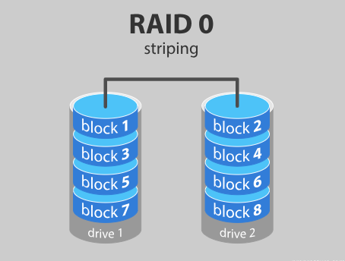

RAID 1: Mirroring (Safety)

* How it works: Copies the same data to 2 drives.
* Purpose: Gives data protection (backup)
* Drives needed: Minimum 2
* RAID 1 = 1 backup copy

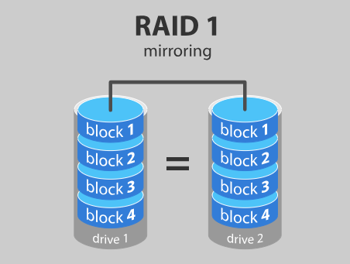

RAID 5 – Striping with Parity (Balanced)

* How it works: Data + parity spread across 3+ drives
* Purpose: Speed + data protection
* Drives needed: Minimum 3

RAID 5 = Fast + Safe, needs 3 or more drives

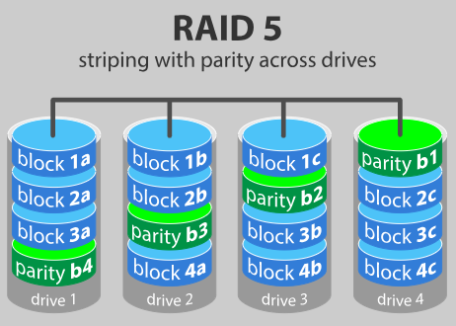

RAID 6 – Striping with Double Parity (Extra Safe)

* How it works: Like RAID 5 but with 2 parity blocks
* Purpose: Can survive 2 drive failures
* Drives needed: Minimum 4

RAID 6 = Safe even if 2 drives fail

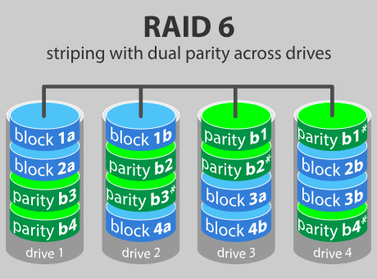

RAID 10 (1+0) – Mirroring + Striping

* How it works: Combines RAID 1 (mirror) and RAID 0 (speed)
* Purpose: High speed + high data protection
* Drives needed: Minimum 4

RAID 10 = Best of RAID 1 + RAID 0

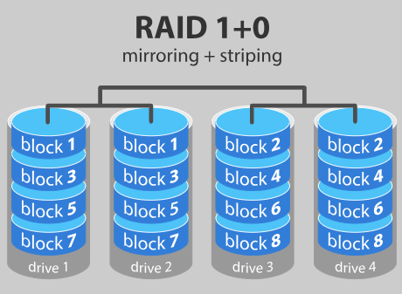

**Section 4: Practical Application**

10. Demonstrate how to replace a CPU fan in a desktop computer.

**Ans**:

* Shut down the pc properly & unplug the cables than open it.
* Find the fan sitting on top of the CPU heatsink in the middle of the motherboard.
* Gently pull out the cable connected to the motherboard.
* Unscrew or unclip the fan from the heatsink (remove old fan).
* Insert a new CPU fan and lock with the screws.
* plug in the Efan wire in to CPU fan slot.
* Close the case & turn on the PC and test it.

**Section 5: Essay**

1. Discuss the importance of regular maintenance for computer hardware and provide examples of maintenance tasks.

Importance of Regular Hardware Maintenance

1. Prolongs Hardware Lifespan  
   Regular cleaning and proper care prevent components such as fans, hard drives, and power supplies from failing prematurely.
2. Prevents Overheating  
   Dust buildup can block ventilation, causing overheating, which may damage components like the CPU or GPU.
3. Improves System Performance  
   Keeping hardware clean and updating drivers ensures smoother performance and reduces the risk of crashes or slowdowns.
4. Enhances Data Security  
   Maintenance includes checking for loose connections or failing drives, helping prevent sudden data loss.
5. Cost-Effective  
   Preventive maintenance reduces the likelihood of expensive repairs or the need to replace components.

Examples of Computer Hardware Maintenance Tasks

* Cleaning and Dust Removal:  
  Use compressed air or soft brushes to remove dust from fans, power supply units, and other components.
* Checking and Replacing Thermal Paste:  
  Reapplying thermal paste on the CPU can improve heat transfer and cooling efficiency.
* Cable Management:  
  Organizing cables to improve airflow inside the computer case.
* Inspecting and Tightening Connections:  
  Ensuring all power and data cables are properly connected.
* Testing and Monitoring Hardware:  
  Running diagnostic tools to check the health of hard drives, RAM, and other components.
* Updating Drivers and Firmware:  
  Keeping BIOS and device drivers up-to-date for better compatibility and performance.
* Checking for Hardware Wear:  
  Looking for signs of damage or corrosion, especially on ports and connectors.
* Replacing Worn-Out Components:  
  Swapping failing hard drives, degraded fans, or CMOS batteries.